Name : Tushar Pathak
RegNumber : 230905396
Roll Number: B48

Lab 9: Programs for Matrix using CUDA(continued...)

Q1)Write a program in CUDA to perform parallel Sparse Matrix - Vector multiplication using com- pressed sparse row (CSR) storage format. Represent the input sparse matrix in CSR format in the host code.

Code:
#include <stdio.h>
#include <stdlib.h>
#include <cuda_runtime.h>

__global__ void spmv(int rows, float* data, int* col_index, int* row_ptr, float* x, float* y) {
int row = blockIdx.x * blockDim.x + threadIdx.x;
if (row < rows) {
float sum = 0.0f;
for (int i = row_ptr[row]; i < row_ptr[row + 1]; i++) {
sum += data[i] * x[col_index[i]];
}
y[row] = sum;
}
}

int main() {
int rows, cols;
printf("Enter dimensions of sparse matrix: ");
scanf("%d%d", &rows, &cols);

float *data = (float*)malloc(rows * cols * sizeof(float));
int *col_index = (int*)malloc(rows * cols * sizeof(int));
int *row_ptr = (int*)malloc((rows + 1) * sizeof(int));
row_ptr[0] = 0;

int k = 0;
printf("Enter matrix elements:\n");
for (int i = 0; i < rows; i++) {
for (int j = 0; j < cols; j++) {
float val;
scanf("%f", &val);
if (val != 0) {
data[k] = val;
col_index[k++] = j;
}
}
row_ptr[i + 1] = k;
}

float *X = (float*)malloc(cols * sizeof(float));
float *Y = (float*)malloc(rows * sizeof(float));
printf("Enter vector: ");
for (int i = 0; i < cols; i++) scanf("%f", &X[i]);

float *d_data, *d_X, *d_Y;
int *d_col_index, *d_row_ptr;

cudaMalloc(&d_data, k * sizeof(float));
cudaMalloc(&d_col_index, k * sizeof(int));
cudaMalloc(&d_row_ptr, (rows + 1) * sizeof(int));
cudaMalloc(&d_X, cols * sizeof(float));
cudaMalloc(&d_Y, rows * sizeof(float));

cudaMemcpy(d_data, data, k * sizeof(float), cudaMemcpyHostToDevice);
cudaMemcpy(d_col_index, col_index, k * sizeof(int), cudaMemcpyHostToDevice);
cudaMemcpy(d_row_ptr, row_ptr, (rows + 1) * sizeof(int), cudaMemcpyHostToDevice);
cudaMemcpy(d_X, X, cols * sizeof(float), cudaMemcpyHostToDevice);

dim3 threadsPerBlock(256, 1, 1);
dim3 blocksPerGrid((rows + threadsPerBlock.x - 1) / threadsPerBlock.x, 1, 1);

spmv<<<blocksPerGrid, threadsPerBlock>>>(rows, d_data, d_col_index, d_row_ptr, d_X, d_Y);

cudaMemcpy(Y, d_Y, rows * sizeof(float), cudaMemcpyDeviceToHost);

printf("Result Vector:\n");
for (int i = 0; i < rows; i++) printf("%f ", Y[i]);
printf("\n");

cudaFree(d_data);
cudaFree(d_col_index);
cudaFree(d_row_ptr);
cudaFree(d_X);
cudaFree(d_Y);
free(X); free(Y); free(data); free(col_index); free(row_ptr);
return 0;
}

Output :

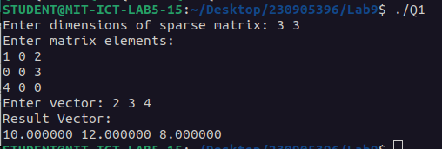

Q2)Write a program in CUDA to read MXN matrix A and replace 1st row of this matrix by same elements, 2nd row elements by square of each element and 3rd row elements by cube of each element and so on.

Code:

#include <stdio.h>
#include <stdlib.h>
#include <math.h>
#include <cuda_runtime.h>

__global__ void raise(int* mat, int rows, int cols) {
int row = blockIdx.x * blockDim.x + threadIdx.x;
if (row < rows) {
for (int col = 0; col < cols; col++) {
int val = mat[row * cols + col];
int res = 1;
for (int i = 0; i < (row + 1); i++) res *= val;
mat[row * cols + col] = res;
}
}
}

int main() {
int rows, cols;
printf("Enter dimensions (rows cols): ");
scanf("%d %d", &rows, &cols);

int size = rows * cols * sizeof(int);
int *mat = (int*)malloc(size);

printf("Enter matrix elements:\n");
for (int i = 0; i < rows * cols; i++) scanf("%d", &mat[i]);

int *d_mat;
cudaMalloc(&d_mat, size);
cudaMemcpy(d_mat, mat, size, cudaMemcpyHostToDevice);

dim3 block(256, 1, 1);
dim3 grid((rows + block.x - 1) / block.x, 1, 1);

raise<<<grid, block>>>(d_mat, rows, cols);

cudaMemcpy(mat, d_mat, size, cudaMemcpyDeviceToHost);

printf("Result Matrix:\n");
for (int i = 0; i < rows; i++) {
for (int j = 0; j < cols; j++) printf("%d ", mat[i * cols + j]);
printf("\n");
}

cudaFree(d_mat);
free(mat);
return 0;
}

Output:

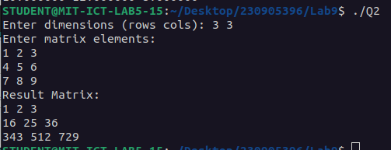

Q3) Write a CUDA program that reads a matrix A of size MXN and produce an output matrix B of same size such that it replaces all the non-border elements(numbers in bold) of A with its equivalent I's complement and remaining elements same as matrix A.
Code:
#include <stdio.h>
#include <stdlib.h>
#include <cuda_runtime.h>

__device__ int flip(int n) {
if (n == 0) return 1;
int n1 = n;
int bits = 0;
while (n1 > 0) {
bits++;
n1 >>= 1;
}
int result = 0, power = 1;
for (int i = 0; i < bits; i++) {
int bit = (n >> i) & 1;
bit = !bit;
result += bit * power;
power *= 10;
}
return result;
}

__global__ void transform(int *A, int *B, int rows, int cols) {
int j = blockIdx.x * blockDim.x + threadIdx.x;
int i = blockIdx.y * blockDim.y + threadIdx.y;

if (i < rows && j < cols) {
if (i == 0 || j == 0 || i == rows - 1 || j == cols - 1) {
B[i * cols + j] = A[i * cols + j];
} else {
B[i * cols + j] = flip(A[i * cols + j]);
}
}
}

int main() {
int rows, cols;
printf("Enter rows and cols: ");
if (scanf("%d %d", &rows, &cols) != 2) return -1;

size_t size = rows * cols * sizeof(int);
int *h_A = (int*)malloc(size);
int *h_B = (int*)malloc(size);

printf("Enter matrix A:\n");
for (int i = 0; i < rows; i++) {
for (int j = 0; j < cols; j++) {
scanf("%d", &h_A[i * cols + j]);
}
}

int *d_A, *d_B;
cudaMalloc(&d_A, size);
cudaMalloc(&d_B, size);
cudaMemcpy(d_A, h_A, size, cudaMemcpyHostToDevice);

dim3 threadsPerBlock(16, 16);

dim3 blocksPerGrid((cols + threadsPerBlock.x - 1) / threadsPerBlock.x, (rows + threadsPerBlock.y - 1) / threadsPerBlock.y);

transform<<<blocksPerGrid, threadsPerBlock>>>(d_A, d_B, rows, cols);
cudaMemcpy(h_B, d_B, size, cudaMemcpyDeviceToHost);
printf("\nOutput Matrix:\n");
for (int i = 0; i < rows; i++) {
for (int j = 0; j < cols; j++) {
printf("%d ", h_B[i * cols + j]);
}
printf("\n");
}
cudaFree(d_A);
cudaFree(d_B);
free(h_A);
free(h_B);

return 0;
}
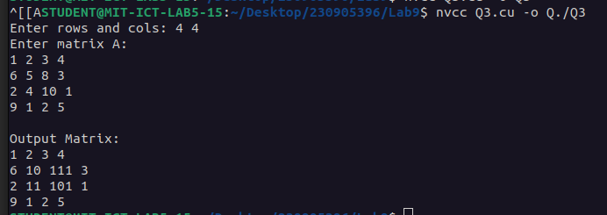
Output:

